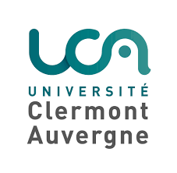
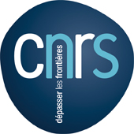
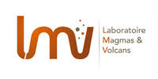

Dear Colleagues,
We are delighted to announce the Sixteenth International Symposium on Experimental Mineralogy, Petrology and Geochemistry (EMPG-XVI), which will be held at Clermont-Ferrand, France, on 17-21 June 2018.
Following the tradition of the EMPG meetings, importance is given to all experimental aspects of Earth Sciences. Contributions to the meeting will be welcomed in the general areas of experimental mineralogy, petrology and geochemistry. This meeting will be particularly devoted to experimental studies involving minerals, magmas, silicate liquids and fluids from the surface to the core of the Earth and other bodies of the solar system. Several areas will receive special emphasis such as: fluids; igneous and metamorphic phase equilibria; magmatic processes, deep mantle, core and planets; elemental and isotope partitioning; mineral physics; diffusion and kinetics; melt physics and chemistry; rheology and deformation; applied and environmental mineralogy; methodological developments.
Opening of abstract submission in January 2018.
Abstract submission deadline 15 March 2018.
A second circular, including information regarding the web site of the meeting, registration and abstract submission will be sent in January 2018. Abstract deadline is 15 March 2018. Registration fees will be around 350 and 250 Euro (full/student) including refreshments and conference dinner.

The EMPG XVI Organizing Committee
Nathalie Bolfan-Casanova, Ali Bouhifd, Maud Boyet, Tahar Hammouda, Ken Koga, Didier Laporte, Muriel Laubier, Geeth Manthilake, Julien Monteux, Socheata Sean.

